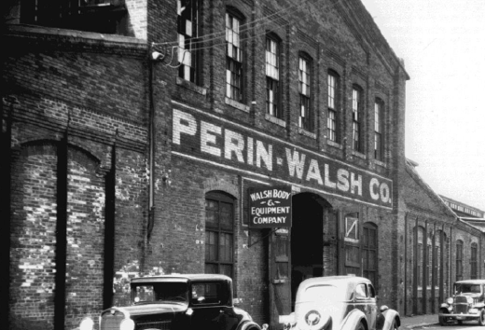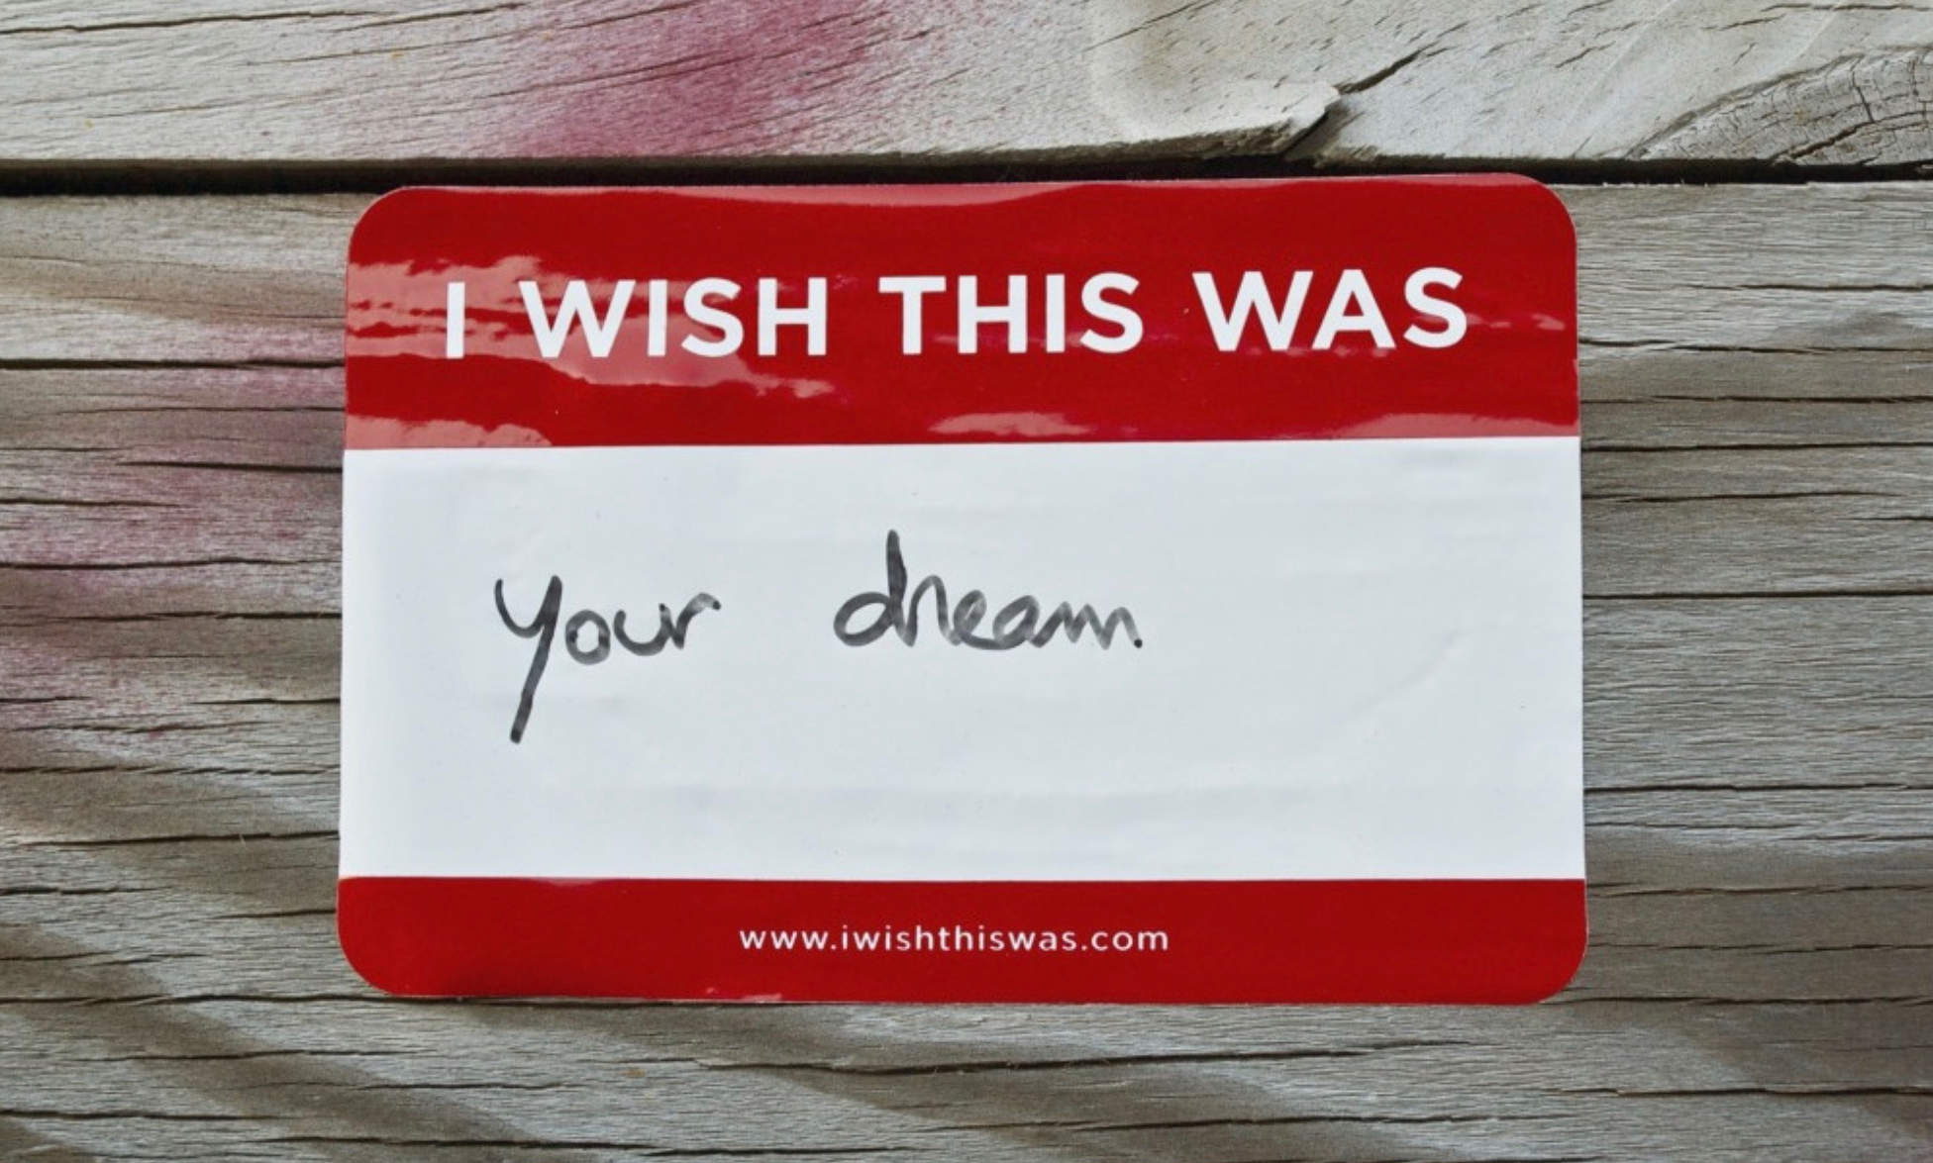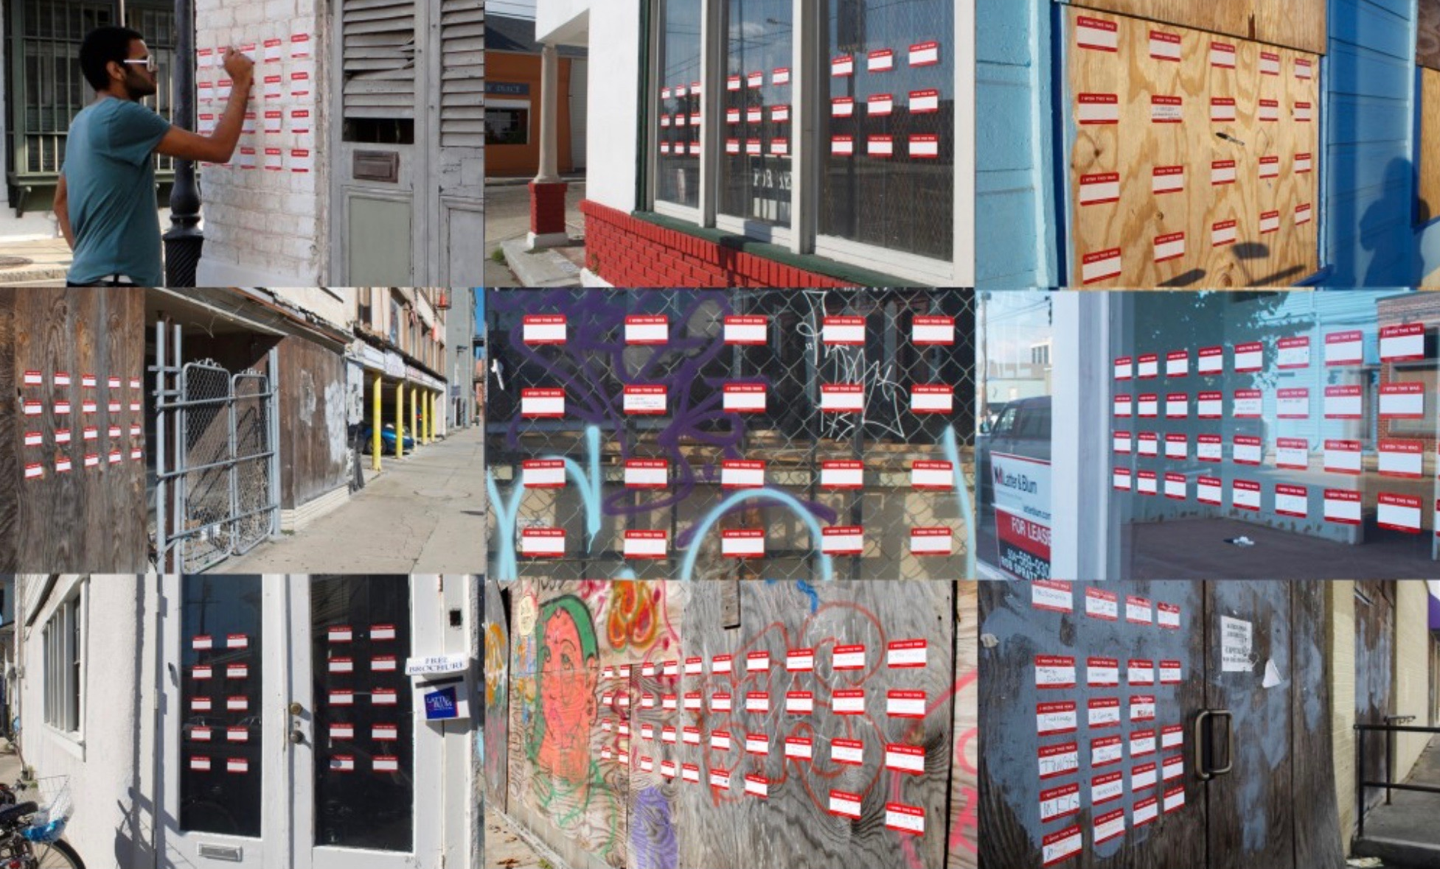
Images from artist Candy Chang’s I Wish This Was

Foundry Community Outreach Team Report July 12, 2019
Community Outreach Team Members: Sue Cusack, Ron Mallis, Stephanie McKay, Martha McKenna, Katherine Shozawa and Joan Squeri

Members of the Foundry Consortium’s Community Outreach Team have been engaged in conversations with members of the Cambridge community in a variety of settings over the past six months. Building on our network of community connections, we have engaged in one-on-one conversations with community leaders to identify how best to spread the word about the Foundry and gather community input on uses for the building and desired programming that would bring the community into the space. We have engaged in conversations with diverse members of the Cambridge community through meetings at non-profit centers, community gatherings, school and church events, arts centers, as well as, continued one-on-one conversations about the Foundry and possible program activities once it opens in 2021. Our goal was to reach a diverse and broad cross-section of Cambridge residents in order to hear their voices to inform the use of building space, such as activities and enjoyable experiences, and opportunities for professional growth and development for years to come.

The Community Outreach Team (COT) members have met with community leaders and stakeholders to plan and facilitate meetings with their community members. These meetings include: sharing information on the Foundry as a future center for creativity, collaboration and education in an historic industrial building; envisioning together what visual and performing arts, STEM and educational programming might bring diverse members of the Cambridge community into the Foundry; and distributing questionnaires for community members to complete on paper or online. We sought input from key stakeholders in the Cambridge community through meetings with residents in particular (youth through senior citizens), artists, school leaders, community organizations, City officials and business leaders by going to where they gathered in community settings. Participation by Cambridge residents provides important information for space use and program planning for the Foundry.

The following summary attempts to capture the variety of outreach activities conducted by the team over the past six months, the major recommendations for space use and programming at the Foundry to support the Cambridge community, and what we have learned to guide our work going forward.

The Foundry Consortium’s Community Outreach Team engaged in conversations with the following Community Groups:

- Community Engagement Team of the Cambridge Community Learning Center (9 women leaders representing diverse cultural and language groupse, including Arabic, Amharic, Bangla, Haitian Creole, and Spanish, and pan-African American communities)
- East Cambridge Planning Team
- Lori Lander's Wednesday Gathering on Arts in Cambridge
- Newtowne Court Tenants Association
- Wellington-Harrington
- The Port
- Area IV Coalition
- Port Café
- Central Square Business Association
- Cambridge Non-Profit Coalition
- Cambridge Community Foundation Recipients of Funding in the Arts and STEM
- Cambridge Art Association
- Agassiz Baldwin Community
- Porter Square Neighbors Association
- Lesley Art + Design Dean’s Community Advisory Council
- Maud Morgan Arts
- MIT List Center
- Central Square Theater
- Massachusetts Production Coalition
- Mayor’s Task Force on the Arts (Community Outreach Team members served on the Task Force)
- Religious Centers: Sacred Heart Church, St Francis of Assisi Church, St. Anthony of Padua Church, Trinity Cambridge Church, Jesus Christ Church of Latter Day Saints, Cambridge African Methodist Episcopal Church and Temple Beth Shalom
- Biogen STAR Foundation Initiative Leaders: Young People's Project, On Route, Breakthrough Greater Boston, Citizens Schools, Cambridge Camping and Cambridge Youth Programs, uAspire, and RootCause
- Cambridge Arts’ Public Art and Exhibitions, City of Cambridge
- Cambridge Rindge and Latin High School
- Cambridge Creativity Commons Advisory Board
- Cambridgeport Neighborhood Association
- Community Art Center
- Cambridge STEAM Advisory Committee
- Cambridge Arts, City of Cambridge
- Individual visual and performing artists

Recommendations for Space Use and Programming (emphasis on Arts) at the Foundry:

The Foundry is a center for civic, cultural and community engagement:
- It is a welcoming, warm, hospitable open space for all residents to feel it is their center.
- Residents need to see themselves belonging through accessible and culturally responsive programming.

Arts Programming
- Temporary art spaces for creating, performing and exhibiting work of community residents
- Artist-in-residence program
- Gallery for local artists to display their work
- Performance space (theater) for local and touring theater, dance and music performances
- Connectivity to other art spaces & groups nearby in Cambridge
- Opportunities for Cambridge Public Schools community performances
Community Gathering Space
- Space for community events for families, elders, youth, young adults and combinations of all four, that are social and educational
- Space for community talks/lectures/conversations
- Space for various community groups to gather for events and celebrations
- Café with a fireplace (as symbolic of the Foundry) with food as a social/cultural connector

Educational and Creative Programming
- Affordable programs in science, technology, engineering, arts and mathematics (STEAM) for professional development and/or personal enjoyment for all residents (professionals and novices)
- Programs for residents to develop skills in traditional and new technologies
- Programs for youth and adults to collaborate in arts production, performance, and exhibition
- Programs in yoga, movement, meditation, crafts, health & wellness, cooking
- Lab spaces – makerspaces and unusual arts spaces - that provide creative resources for people to collaborate in developing skills connected to creative economies

What we have learned that needs to be addressed going forward:

Members of the Cambridge community have expressed an interest in continuing to voice the following concerns:

- How do we hear the voices of youth and adults who remain underrepresented in conversations about arts, theater, and mixed programming?
- What programming will be developed, and by whom? And how much will it cost? This interest is being generated by individuals who would like to participate in programming as well as by organizations that are wondering about the costs to offer programming or utilize space.
- How will the Foundry support the survival and vitality of the arts community in Cambridge (e.g. free to affordable studio space)?
- How will the Foundry connect with the emerging STEAM and arts/community ecosystem as an extension of space and resources for existing programming? This issue is expressed in part by the concerns of organizations who want to be able to sustain their identities and meet the needs of individuals who may not be able to find everything that they need at the Foundry, and will welcome a referral to other organizations more equipped to address their needs.
- How will marketing ensure interest in the Foundry across Cambridge neighborhoods and offset the belief that the Foundry is for East Cambridge residents only?

We recognize that community outreach needs to continue throughout the next phase of planning for the Foundry. We recommend the next steps to continue and expand the dialogue on programming for the Foundry:
- Develop participatory public engagement events, such as artist Candy Chang’s I Wish This Was
- Continue engagement with neighborhood associations
- Increase outreach to youth and underrepresented communities through various networks

